**UNIVERSITY OF GHANA**



**DEPARTMENT OF COMPUTER SCIENCE**

**CSCD 312** ARTIFICIAL INTELLIGENCE

**STUDENT ID:** 10666676

**A MACHINE LEARNING APPROACH TO RECOMMEND POSTS TO USERS BASED ON THIER PREFERENCES**

**PROBLEM DEFINITION**

InfoHub is a business networking and information hub,that provides opportunities for unknown businesses and brands to create accounts and regularly post news-feeds on their pages, to be seen in every parts of the world[1].Users on the hub get to be authenticated consequently,giving the administrator the prospect to track user activities.But how would the administrator assist these businesses to target the users who usually view their posts since the hub does not have any component that allows users to subscribe?How would the administrator boost user experience if users are not being fed with posts of their choices? Hence, there is the need for a recommendation system that eases off the burden of the administrator,promotes these unknown businesses and give users a better adventure.

**OBJECTIVIES**

A recommendation system is an application which is used for prognostics in various disciplines throughout the internet.The information extricated from already searched posts can be fashioned into the prediction of relevant posts for the user[3].Recommendation systems fringe a class of techniques and algorithms which are able to advocate relevant items or posts to users to boost their user experience[4].In this paper, our main intent is to use techniques and algorithms the recommendation system offers to ease the burden of administrators,promote and improve the quality of services offered by businesses on the hub and offer users a better experience on the hub.

**METHODOLOGY**

There are so many techniques and approaches in building a recommendation system.But the use of methodical and precise recommendation techniques is imperative for a system that will lay out good and functional recommendation to its individual users.Fig.1 shows the scrutiny of various recommendation filtering techniques that can be used.

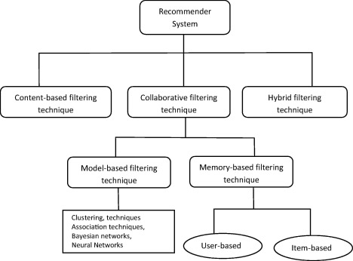

But in this paper, we are going to focus on one of these techniques to solve this problem and generate an coherent and accurate recommendation system for the hub which would match our objectives as stated above[2]. This technique is known as the content-based filtering technique.

**CONTENT-BASED FILTERING**

Content-based filtering is a domain-dependent algorithm which accentuates more on the analysis of attributes of items to spawn predictions.In content-based filtering,recommendation is made based on the user profiles using features extracted from the content of the items or posts that the user has evaluated in the past.Items or Posts that are mostly linked confidently rated items are recommended to the user.At the point when the user changes profile status, content-based filtering still has the aptitude to adjust its recommendations within a very short period of time[2].A user tend to rate certain type of posts he or she likes. His or Her constant read on those posts reflects his or her response towards such posts.

Those previous posts of interest, serves as the “content” in the Content-based filtering.Based on the content,the user is recommended future posts which he might approve of[3].

Here, the user is recommended posts which fall in the particular criteria of preference.

**ALGORITHM**

**Input**:user X, posts p,posts type pt, Number of posts to be recommended(µ).

**Output:**Recommended posts R

1. for all users do
2. Select seen posts s,unseen posts s',association of unseen posts as i ' w.r.t X, association of each criteria ac j w.r.t s', where I is 1 to n and j is 1 to p.
3. Calculate score j
4. Select the highest three score j
5. Select p' ⊂ s' according to the highest three score
6. Calculate score p' where e ∈ p'
7. Return top u score recommendations
8. End for

In this algorithm, the notations used have the following meaning : association of each post as i represents total number of users who rated post i Є s', association of each field af j represents total number of posts belonging to the criteria j.

Score j = ac j / p

score(pe') = ape / total count of p'[3].

**CONCLUSION**

Using the content-based filtering algorithm is an effective approach to recommending posts that users may be interested in. As a result, our objectives stated above can be achieved by using this technique in a recommendation system which would satisfy the needs of the product owners, the businesses that employ their services and the users that engage in the usage of the hub services.

**REFERENCES**

1. InfoHub Mobile:About InfoHub App.

*<https://play.google.com/store/apps/details?id=com.apps.infohubappmobile&hl=en>* **Updated** May 27,2020.

[2] Isinkaye, F.O, Folajimi,Y.O and Ojokoh,B.A . *Recommendation systems: Principles,methods and evaluation, Egyptian Informatics Journal Volume16,Issue 3,November 2015, Pages 261-273.*

**Received** 13 March 2015, **Revised** 8 June 2015, Accepted 30 June 2015, Available on-line 20 August 2015.

[3] Nautiyal Anand and Prasad Mahendra. Machine Learning Algorithm for Recommender System -a comparative analysis ,*International Journal of Computer Applications Technology and Research Volume 6–Issue 2, 97-100, 2017, ISSN:-2319–8656*

[4] Seif George. An Easy Introduction to Machine Learning Recommender Systems.

*[https://www.kdnuggets.com/2019/09/machine-learning-recommender-systems.html#:~:text=Recommender%20systems%20are%20an%20important,to%20follow%20from%20example%20code.](https://www.kdnuggets.com/2019/09/machine-learning-recommender-systems.html" \l ":~:text=Recommender systems are an important,to follow from example code.)*